**PLC Lab Getting Started**

**Lab Objectives**

In this lab you will learn the following:

* Setting up the buffalo router
* Establishing a communication link between the PC and the PLC through the router and obtain the IP address of the PLC.

**Lab Duration**

10 – 15 minutes

**Lab Procedure**

**Setting the Router:**

All the communications to and from the PLC are done through the Buffalo router. The following are preliminary steps to get the router into the system.

1. Connect the Ethernet port on your PC/Laptop to one of the four, 4, ports (not Internet - Blue) on the router.
2. Open any web browser and enter the IP address below. The window labeled 2 below will appear on the screen. Enter the words **admin** and **password** in the window. The router is now configured.
3. If the address is not correct, then use the ipconfig command to find the correct IP address of the router and repeat step 2.



**192.168.10.99**

**Establishing a Link between the PLC and the PC:**

1. Open the Do-more Designer program
2. Click on the **NetEdit 3**. A dialog box will appear.

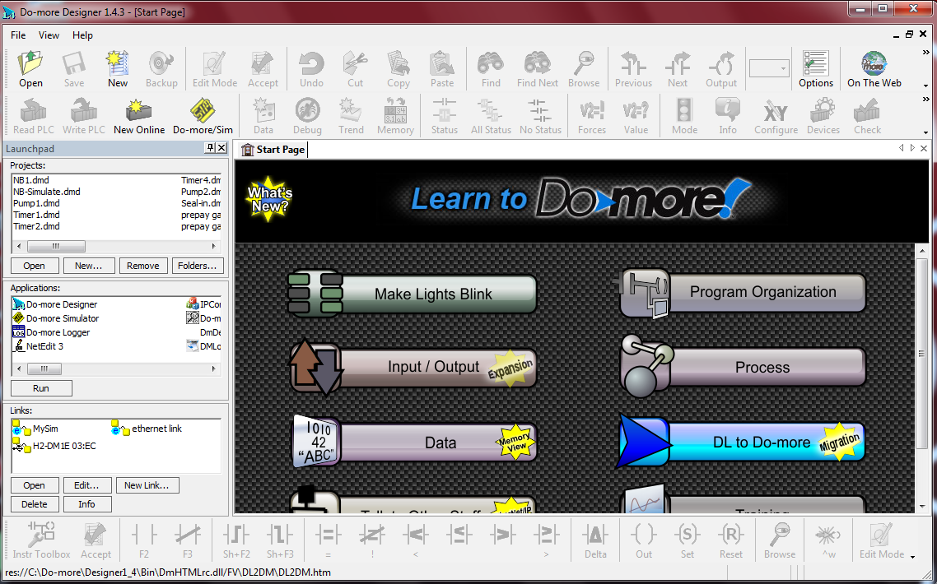

**NetEdit 3**

1. In the window below, select **TCP/IP** Tab and then click on the **IP address** (of the PLC) tab so that a second window (**General Settings**) will appear.

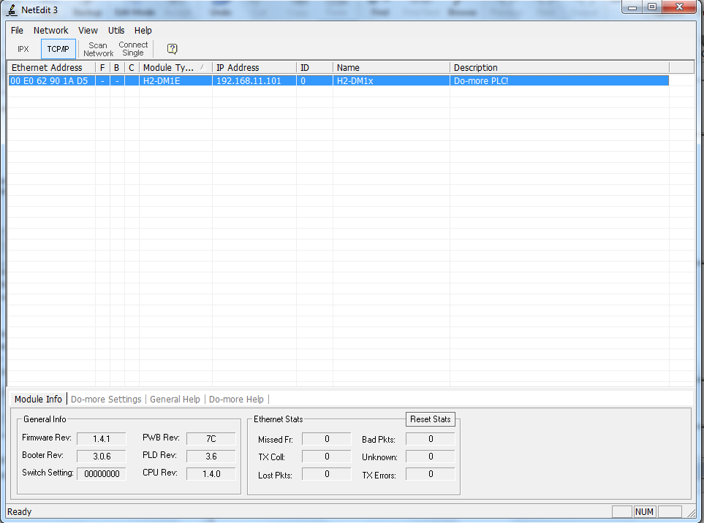

1. If the IP address displayed in the **General Settings** window is different from the one in the above window, then enter the above IP address. Make sure that the **Subnet mask** and **Gateway** numbers are similar to those below. Click **OK** when done.

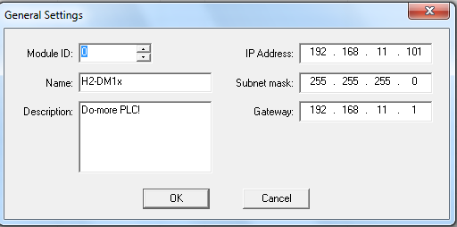

**Note:** If you encounter any problem refer to the file named GettingStarted_CommSetup and titled Communications Setup.